**Group 8 Project Plan**

The proposed plan for this project is to gather and present natural disasters that occurred over the past 60 decades in USA to the end user on a webpage. The end user will have information regarding various aspects of disasters over the past 60 plus years such as – type, date, and areas affected. We propose to have filters based on the above categories, for the end user to search. The webpage will also have interactive visualizations and plots that will be dynamic based on the user input.

Languages and tools that will be used: HTML, JavaScript, CSS, Python, Visual Studio code.

Data Source: FEMA (via Kaggle), format – CSV files

Link to Data sets: <https://www.kaggle.com/headsortails/us-natural-disaster-declarations>

Screenshots of visualizations that inspire us:

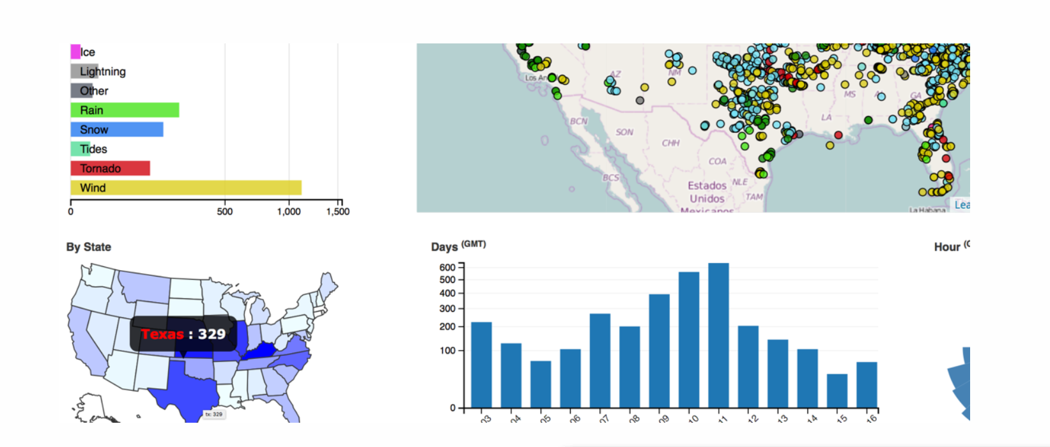

Our goal is to have the above charts and graphs render dynamically. For example, if the user hovers the mouse over a state, data visualizations will change to represent that state. In addition, we will also build text search boxes or drop-down filters for the user to manually enter search criteria.

GitHub repo link: <https://github.com/nirupamashankar/Project_NaturalDisasters>

Text Summary of various disasters/synopsis, just to engage reader

Natural Disasters in USA – A Historic Overview

FEMA Aid deployed – Yes No

How long the incident lasted

Filter by date

Filter by State

Filter by disaster

Interactive map of country. State boundaries drawn.